**Test Results :**

Test_image_1:

Image is in Hindi language



Result:

Translated language with our Application: English

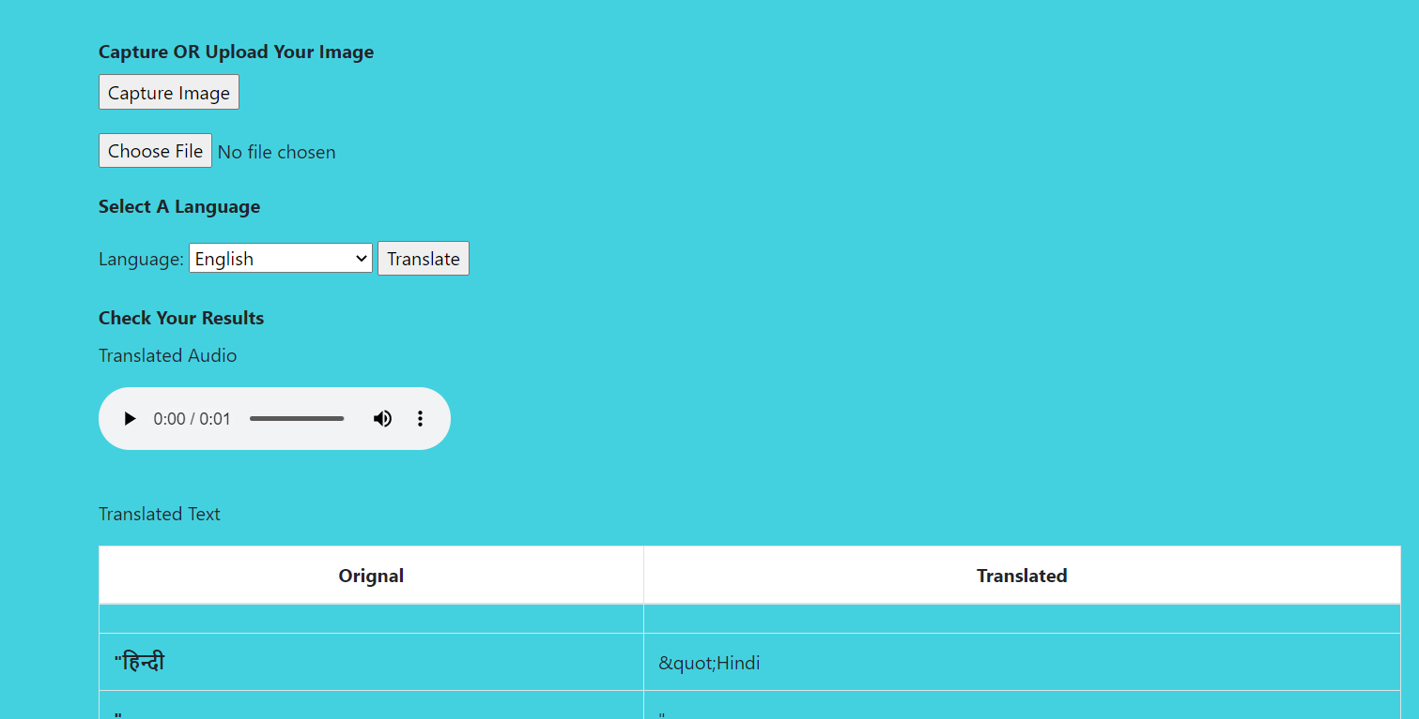

Translate language with our application: Chinese

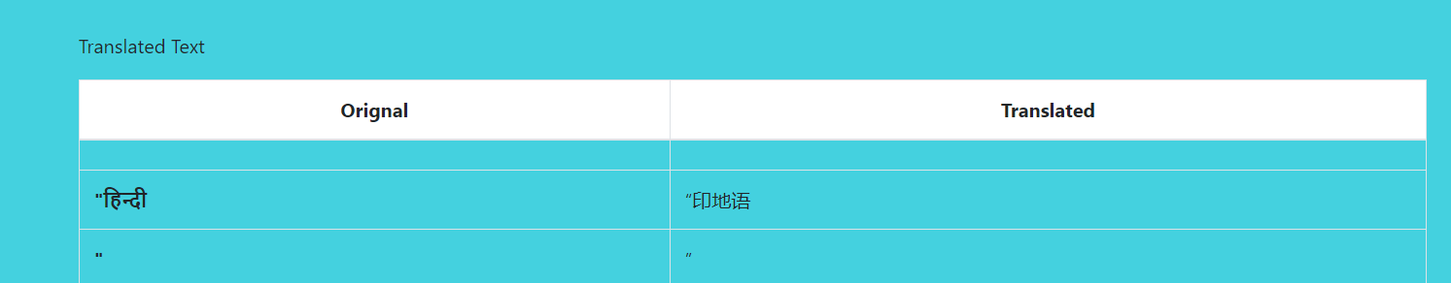

With Google Lens

English Chinese

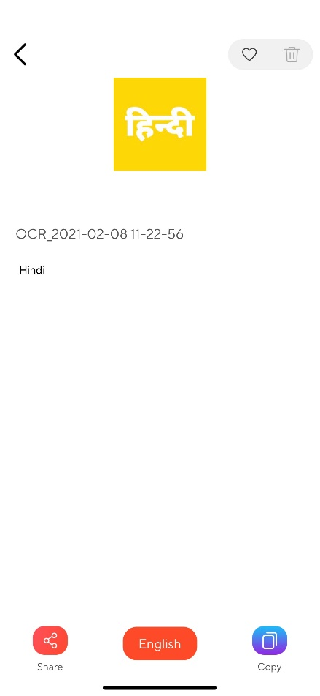 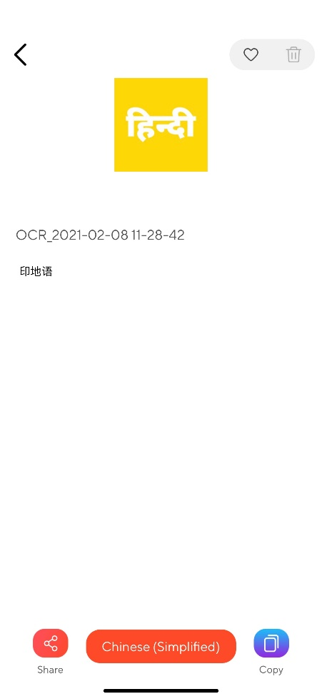

Results are same in both app.

Test Image 2

The Image is in English language

Funny fact here “even the inverted English character which is back of chair is also translated which best knowledge”.



Result as translate language: Chinese.

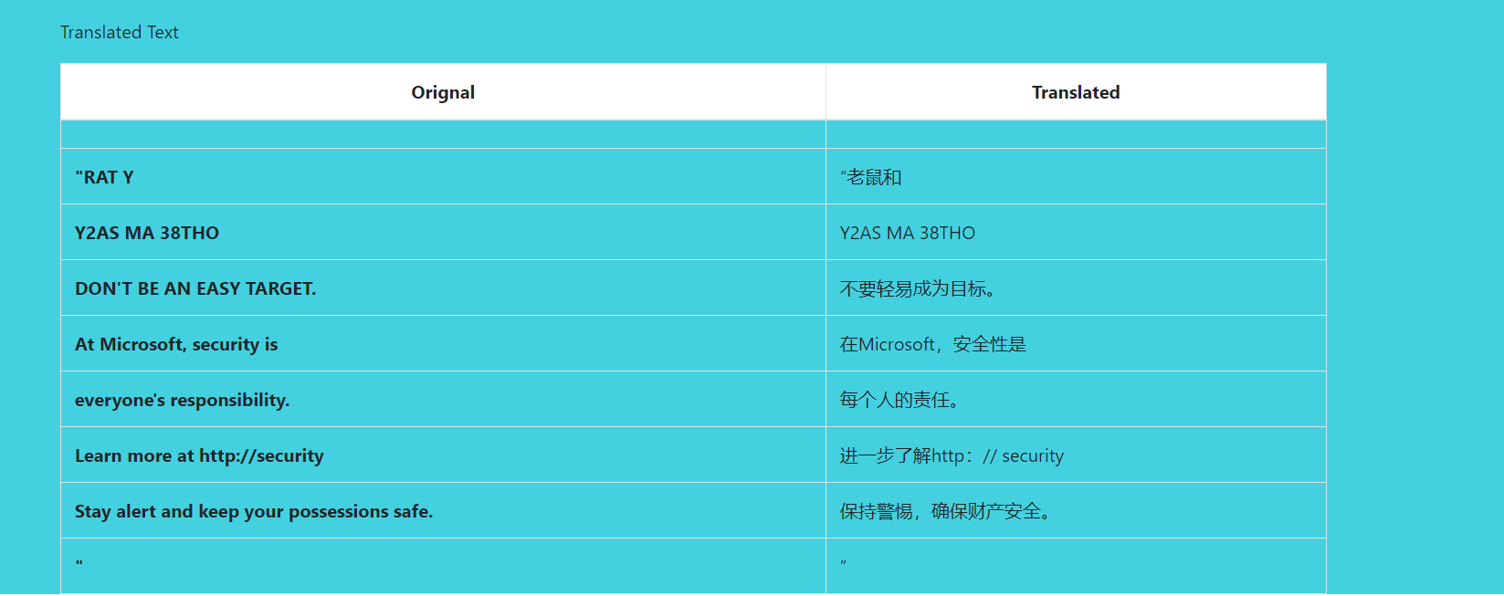

Translate language as : Spanish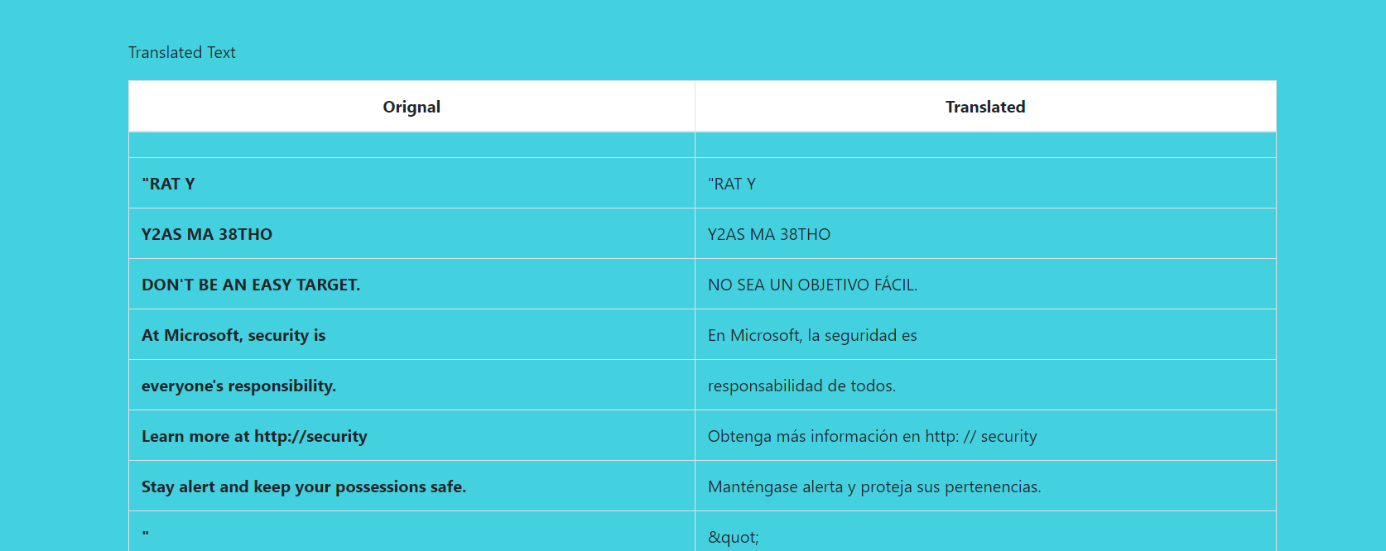

Google Lens Result

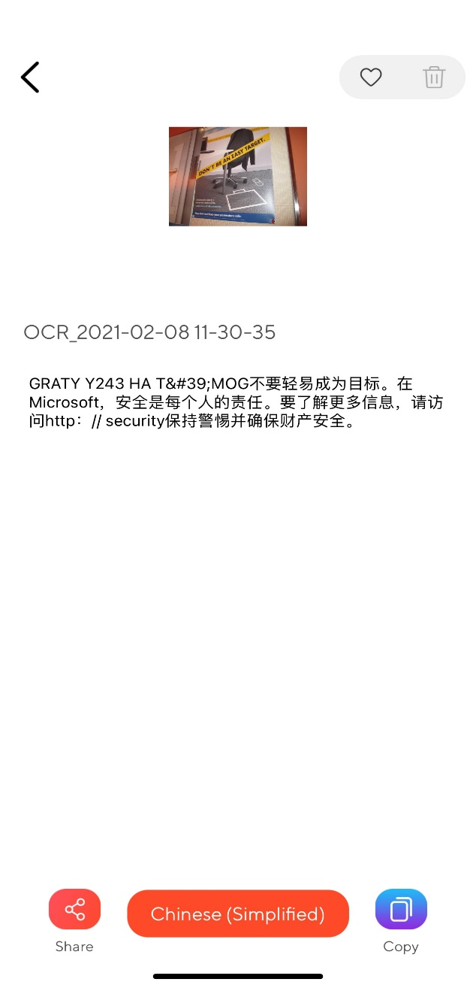 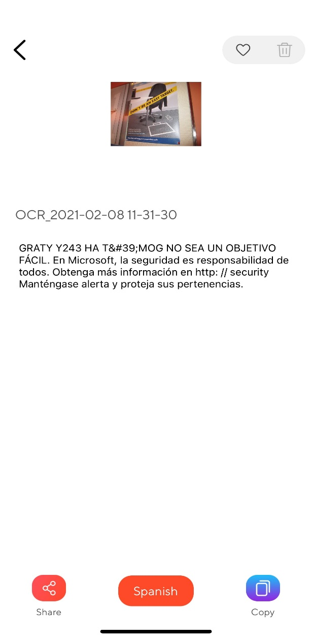

Results are nearly same for both app.

Test_image_3:

Text inside image is in Chinese

Translate result in English.

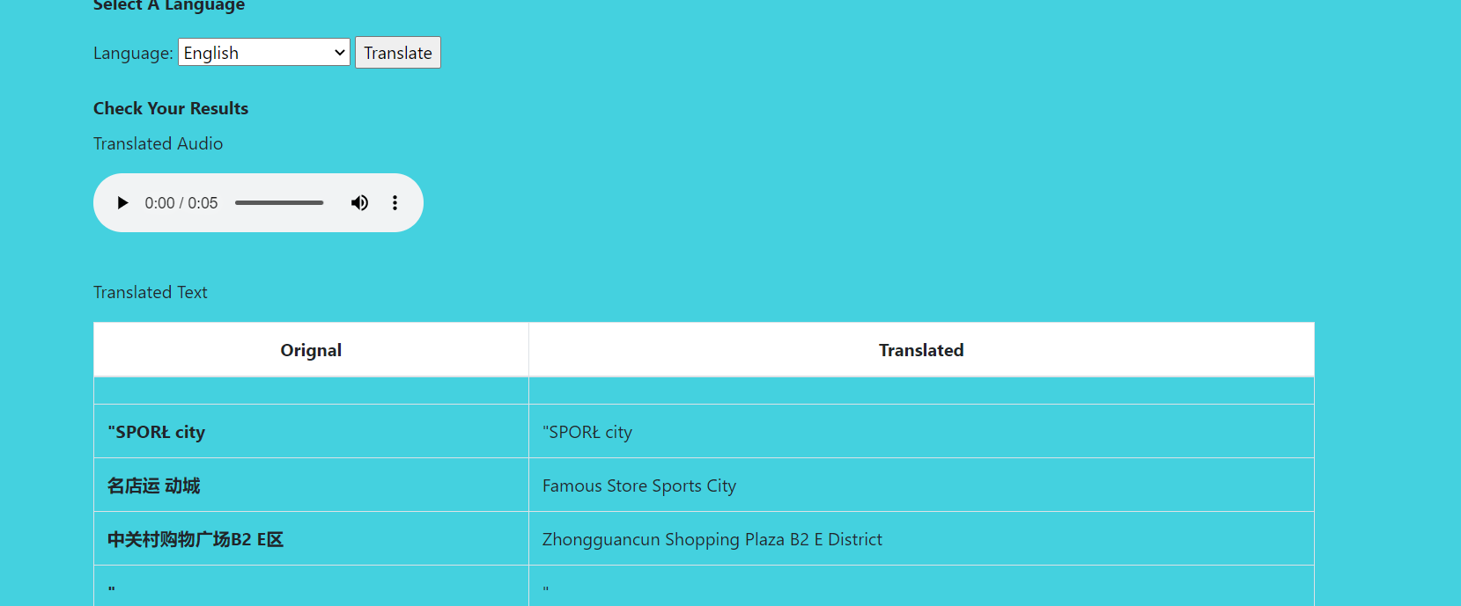

Translated result in Spanish:

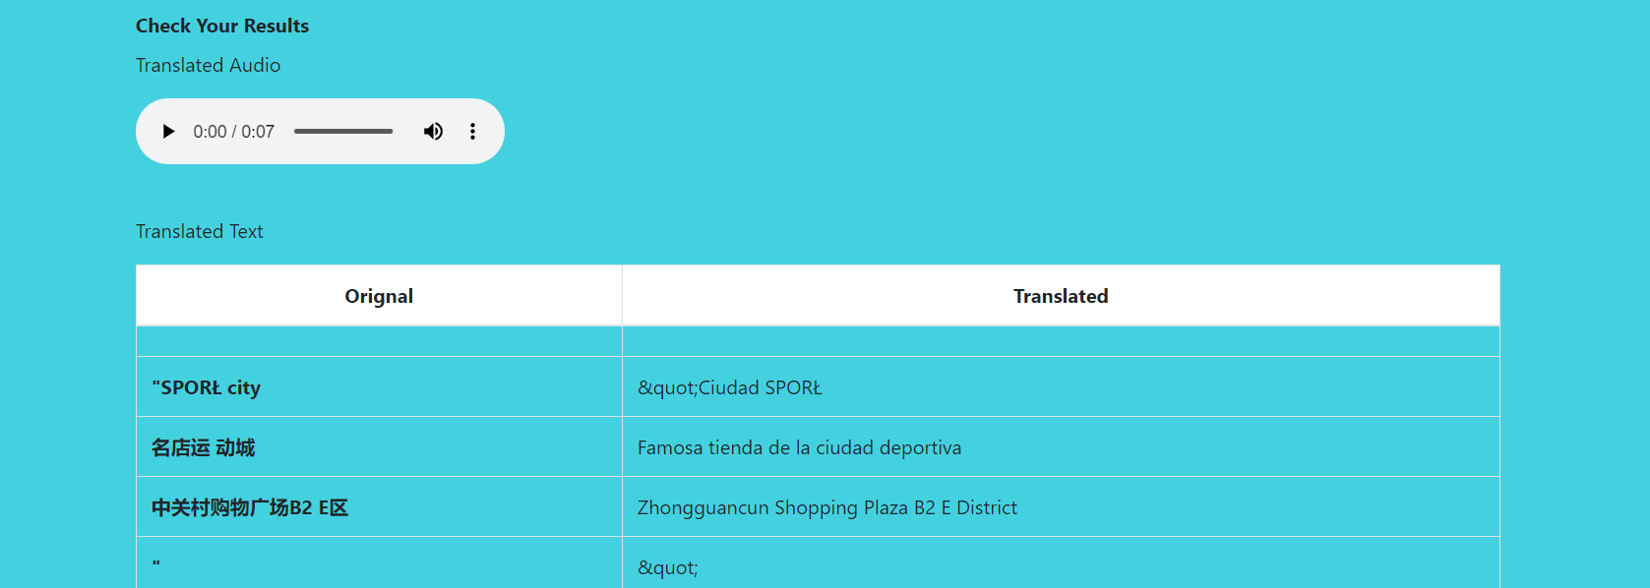

Google Lens Result

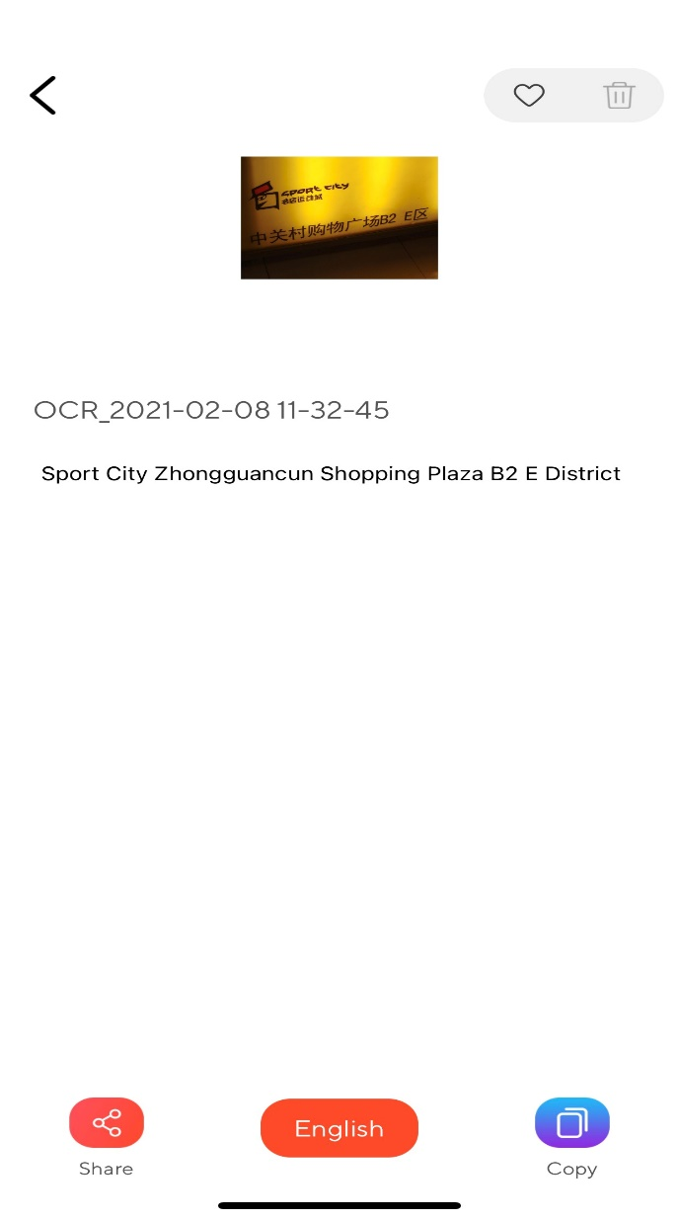 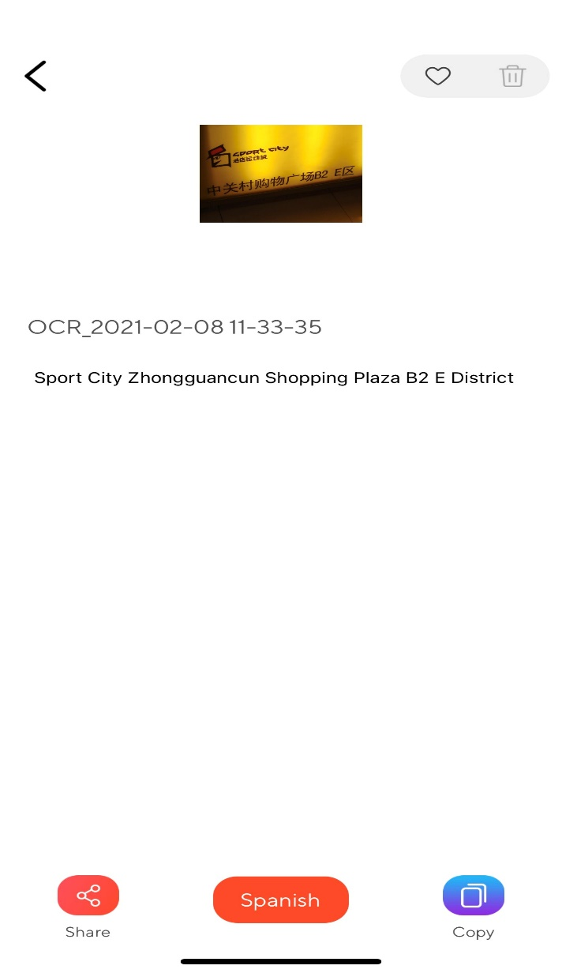

Clearly Our application able to detect more text in image and translated it.

Test Image 4 :

The text in image is in Chinese.



Result with our application in Russian:

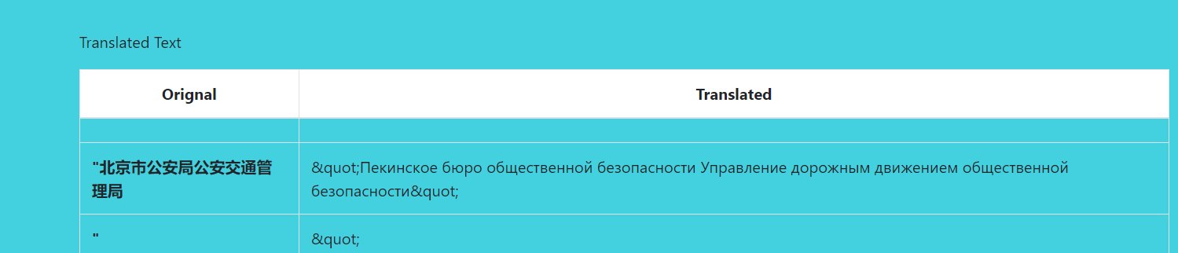

Result with our application in English:

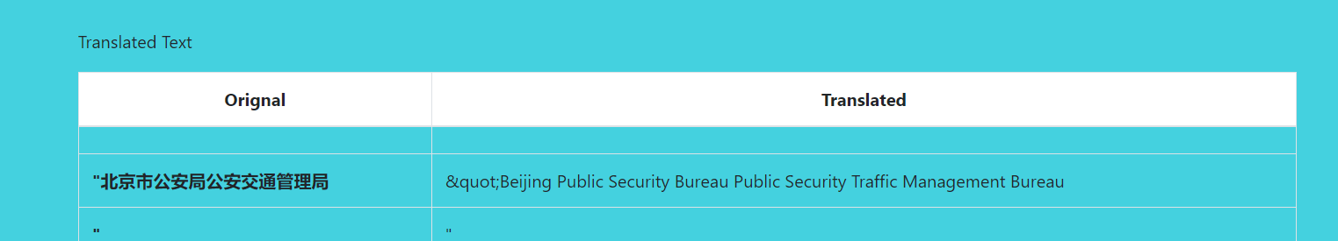

Google Lens Result:

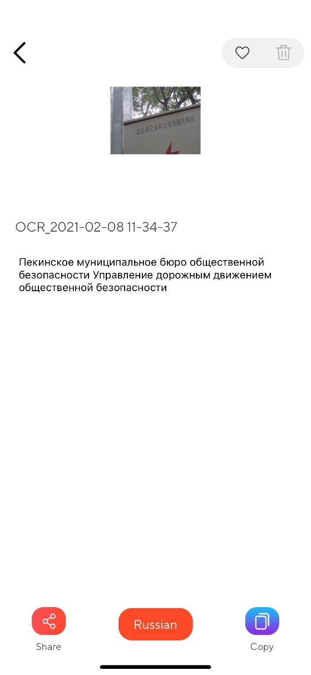 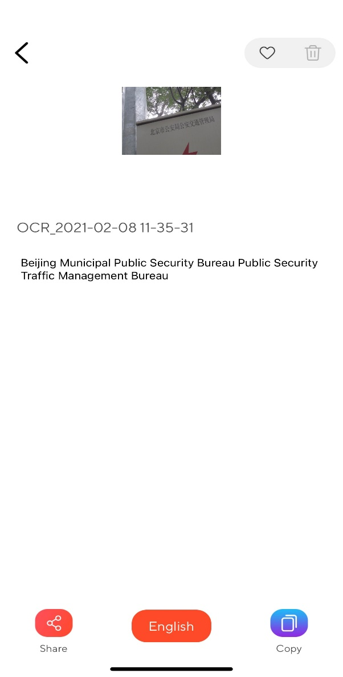

Lens able to detect more characters in this case. Still our application converting the text more meaningfully correct.

Test_image_5:

Text inside image is in English

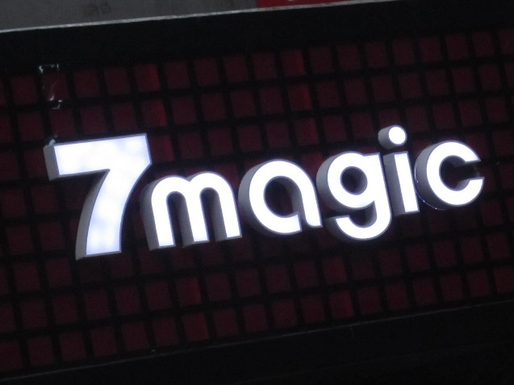

Result with our application in Hindi:

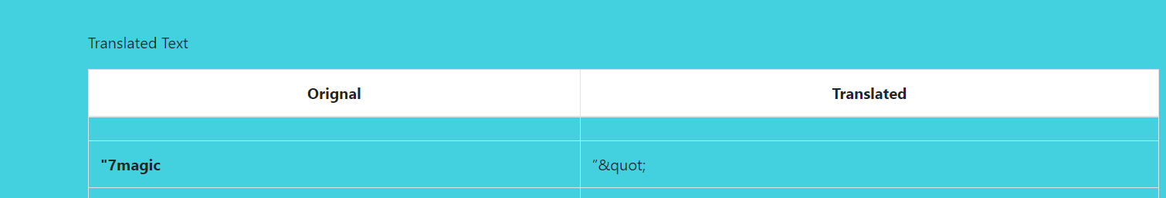

Result with our application in Russian:

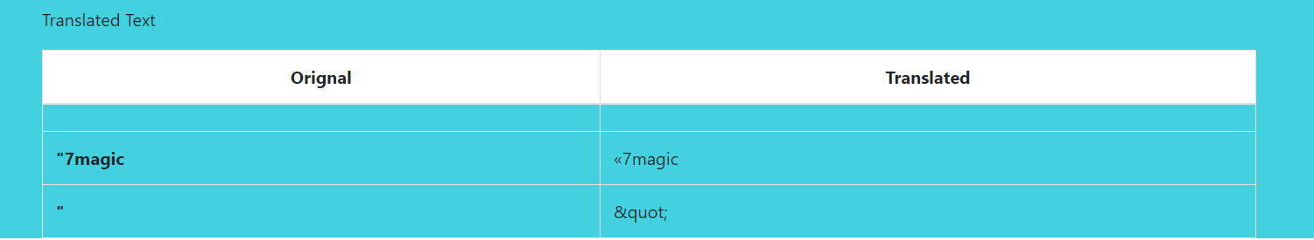

Google Lens Result:

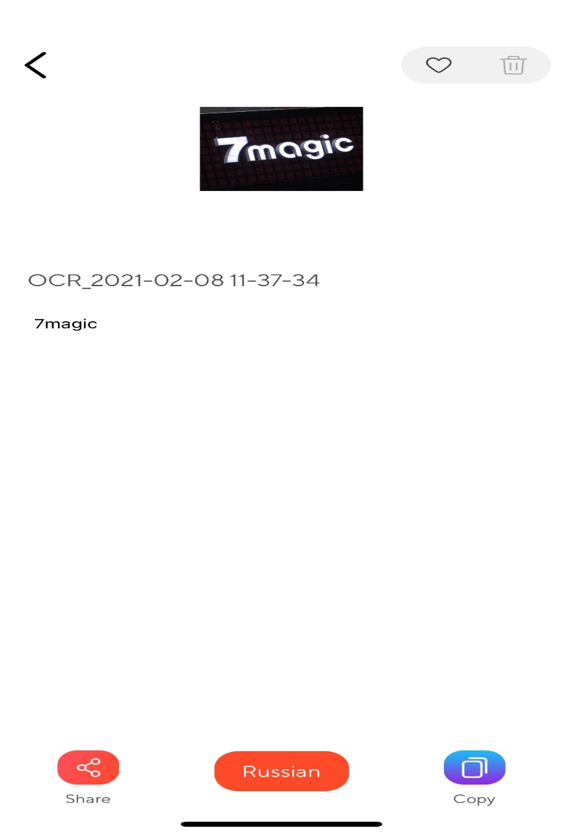 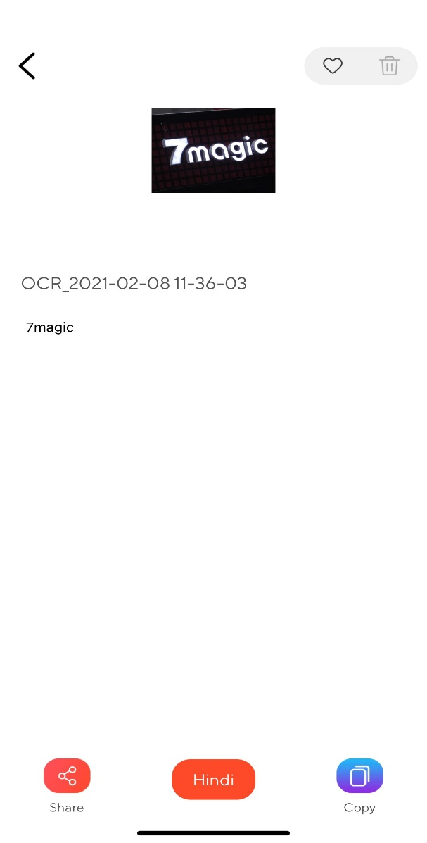

Both app unable to perform translation.

Test_image_6:

Text inside image is in Chinese.

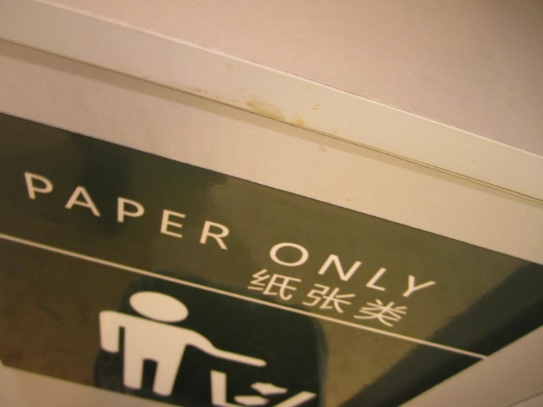

Result with our application in Hindi:

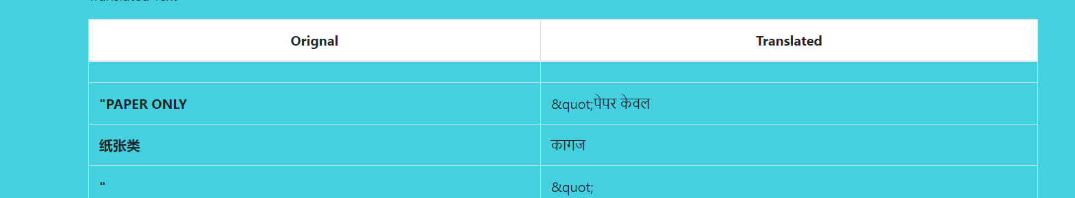

Result with our application in French:

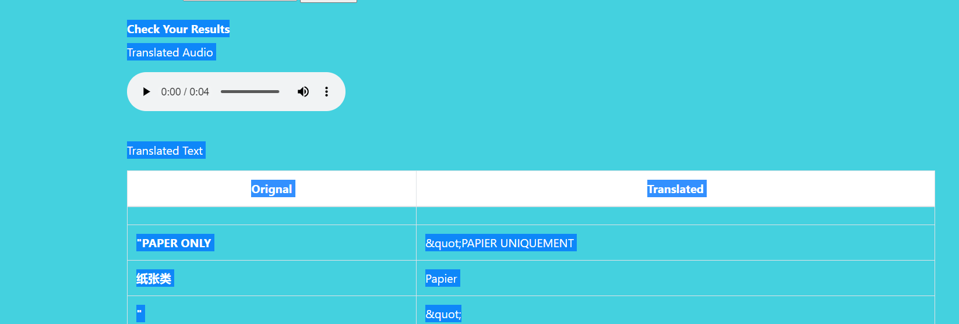

Google Lens

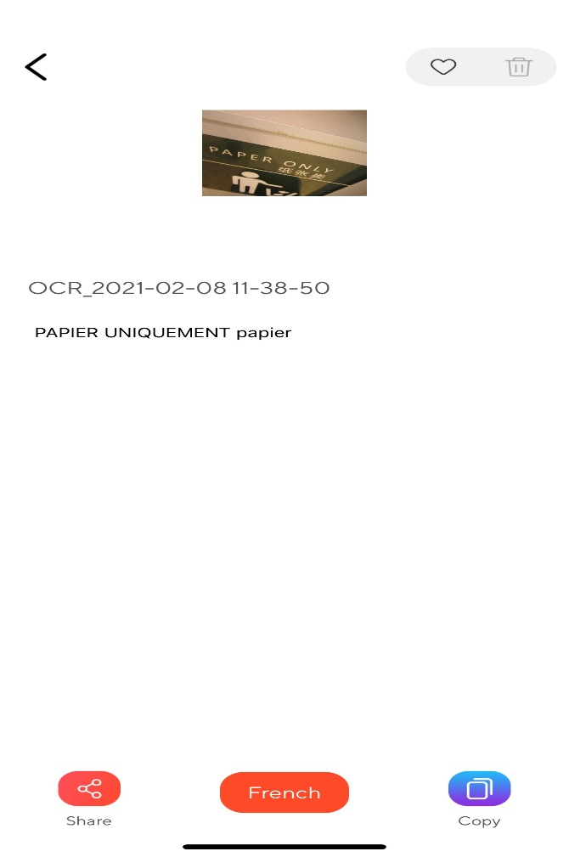 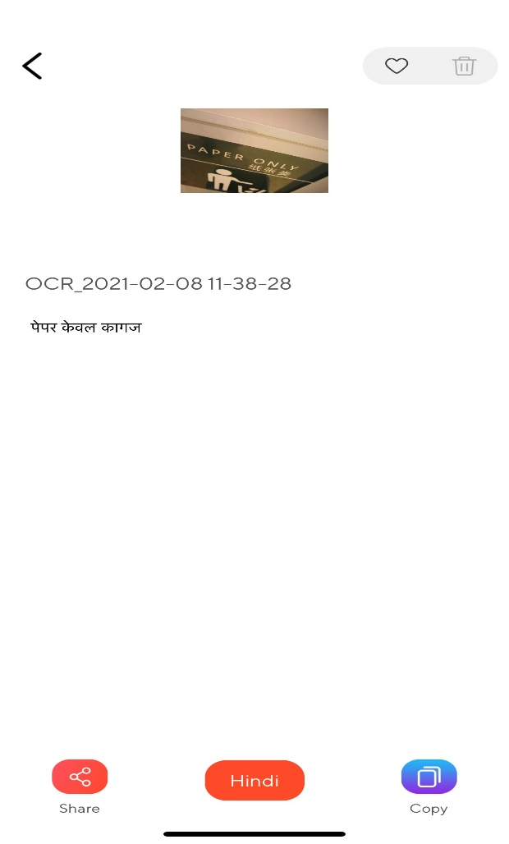

Results for both application are same.

Test_image_7:

Text inside image is in Chinese

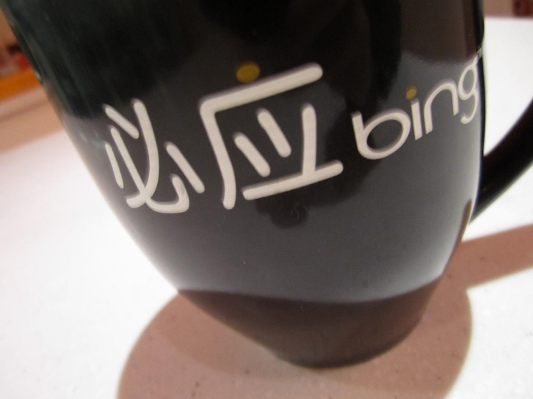

Result with our application in Hindi:

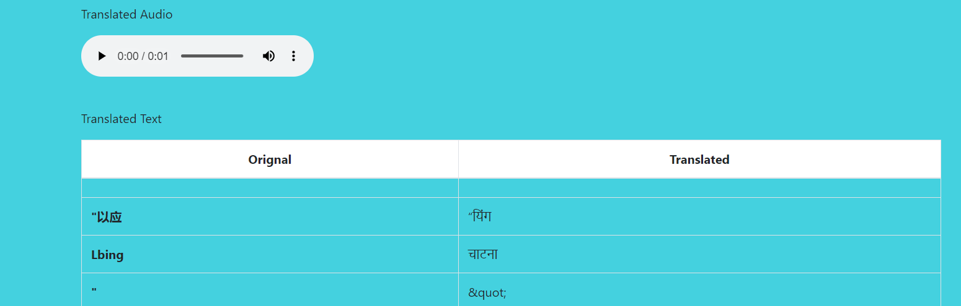

Result with our application in English:

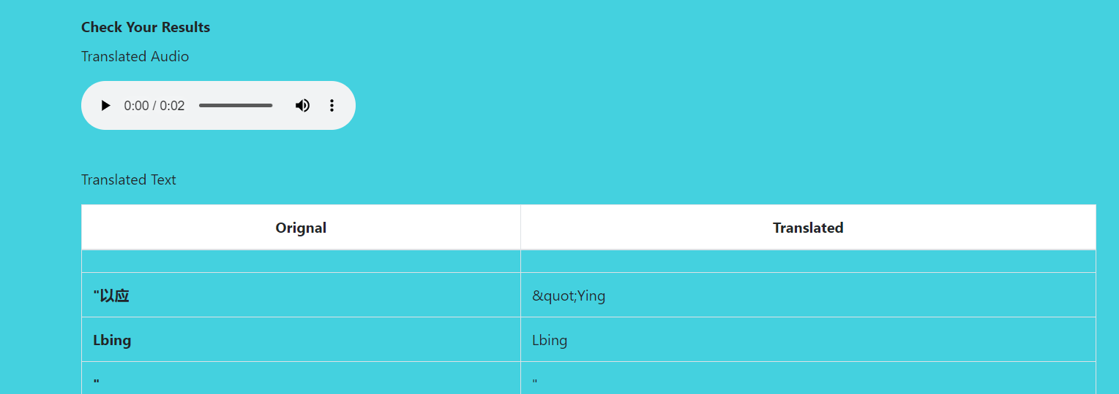

Google Lens Result:

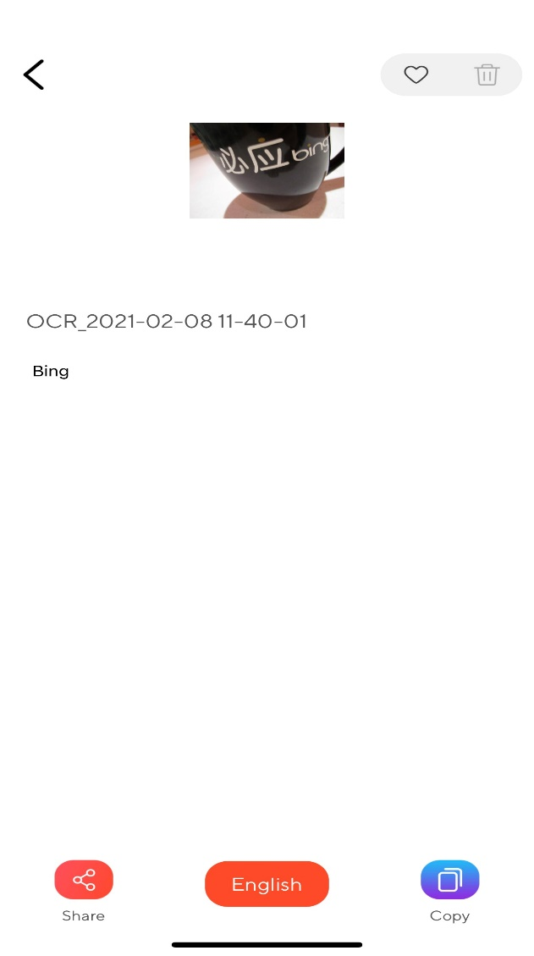 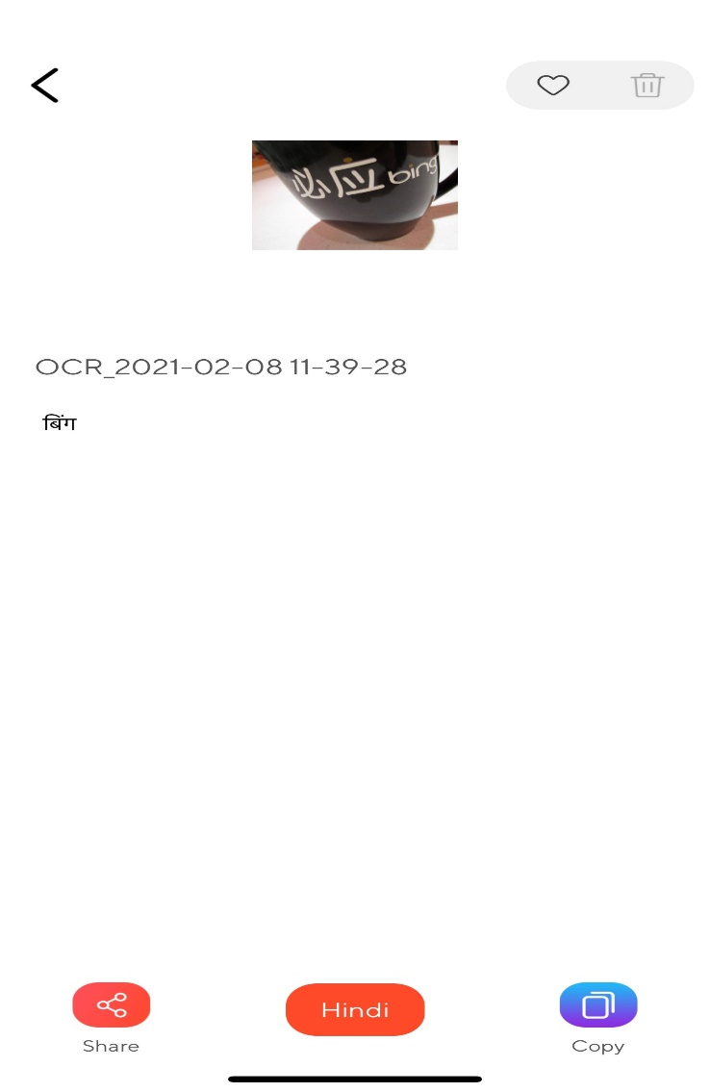

The application read text in different manner it is clear from this test result.

Test_image_8:

Test inside image is in Chinese

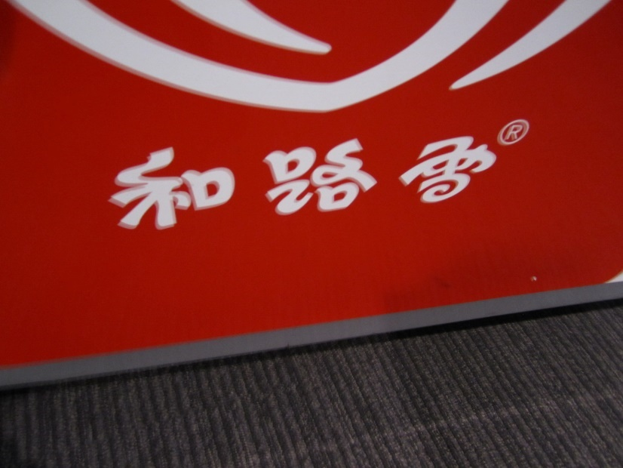

Result with our application in Korean:

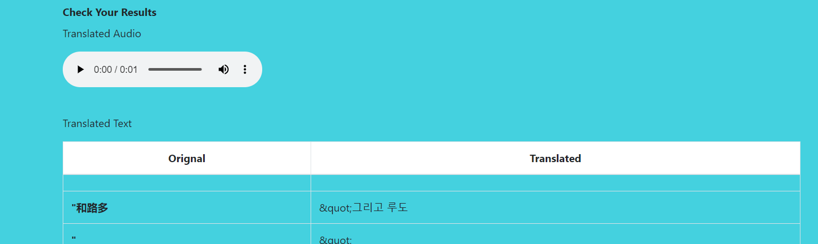

Result with our application in Japanese:

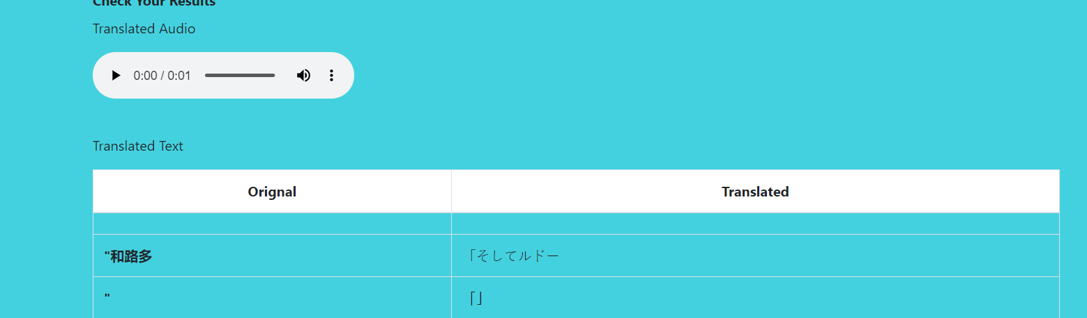

Results of Google Lens:

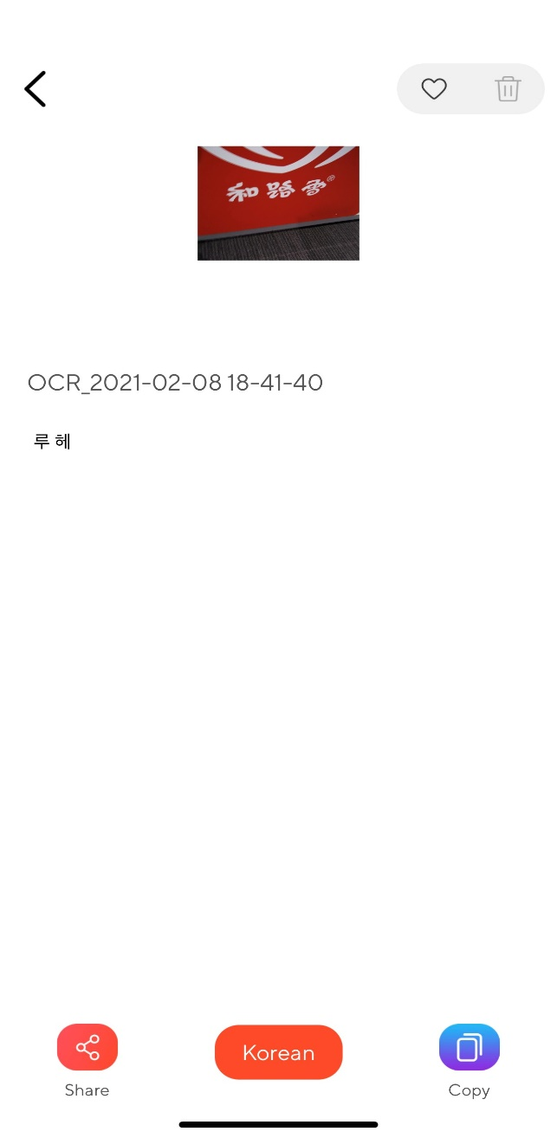 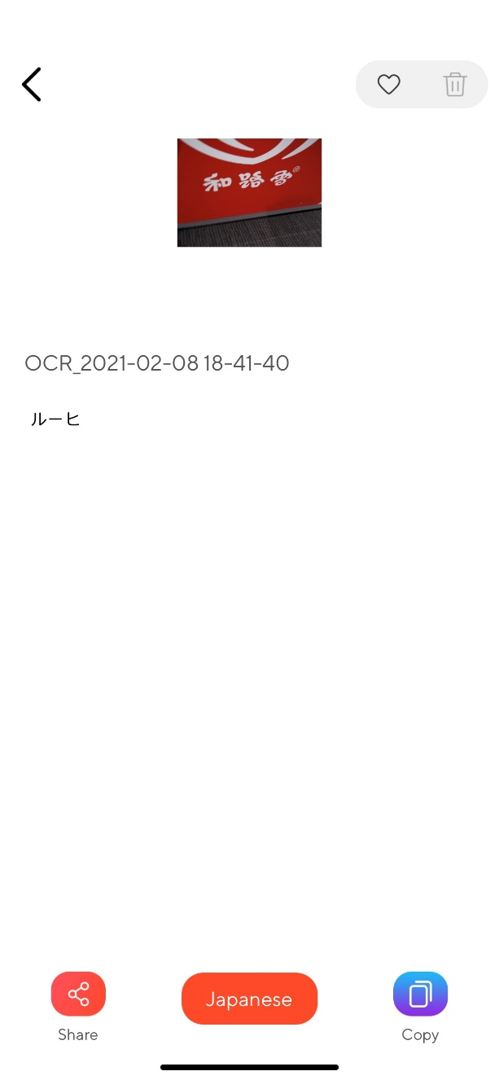

Here the Lens and Our results are completely different. We need to figure out which one is accurate.

Test_image_9:

Text inside image is Chinese

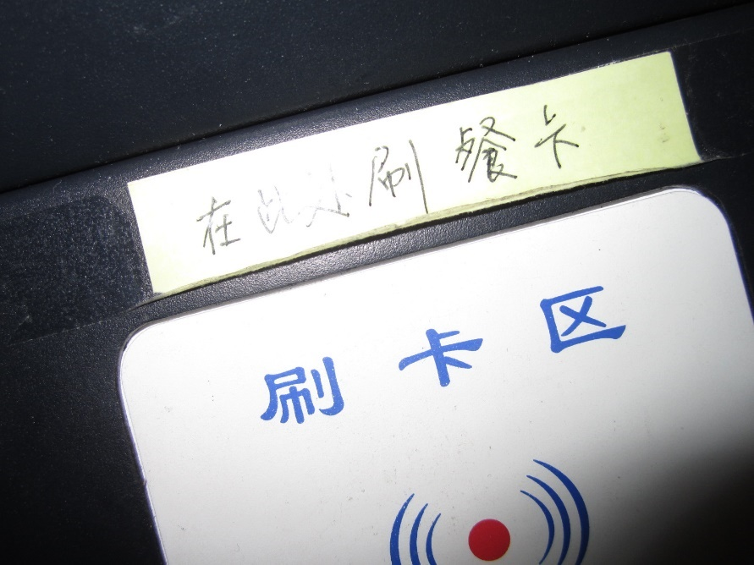

Result with our application in French:

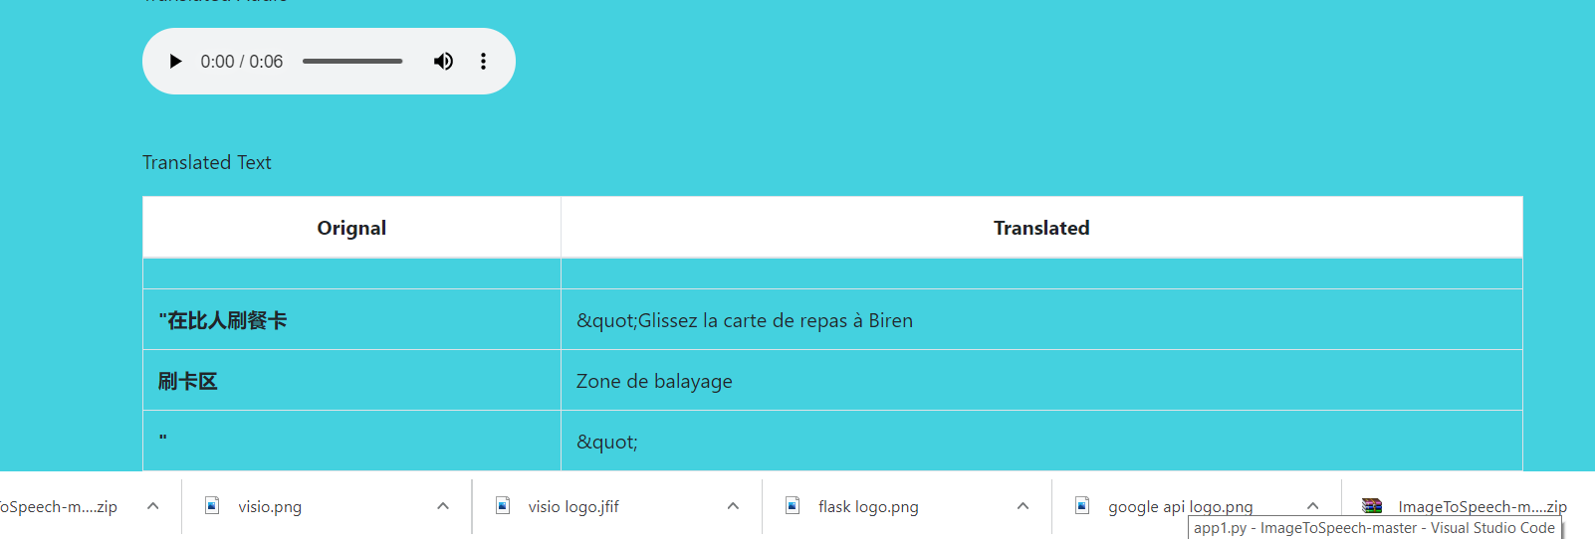

Result with our application in Russian:

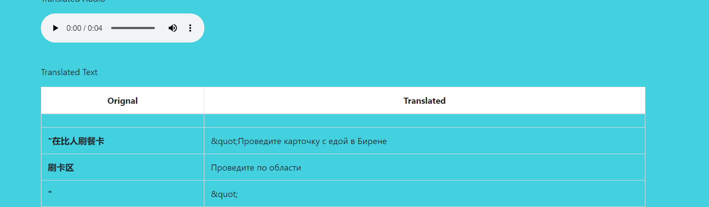

Results with Google Lens:

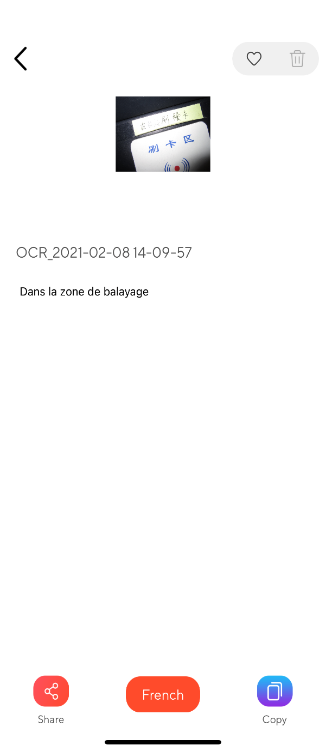 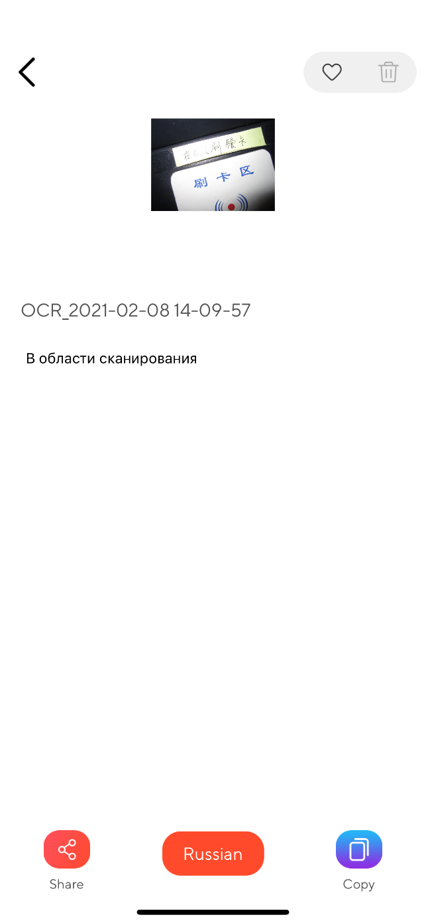

Our application able to convert more text in image.

Test_image_10:

Image in text is in Thai



Result with our application in Korean:

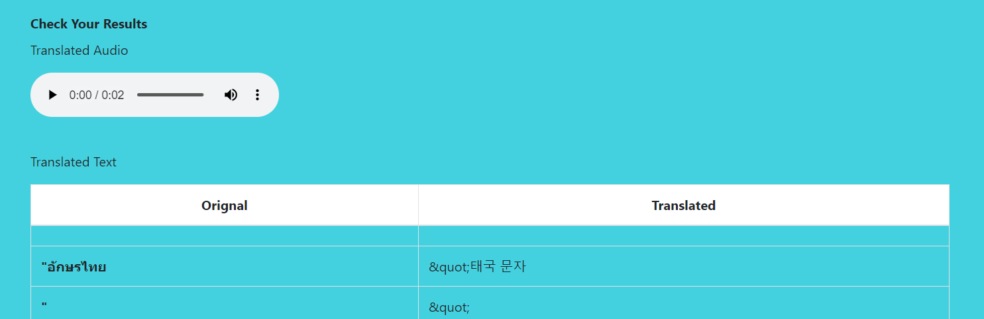

Result with our application in Japanese:

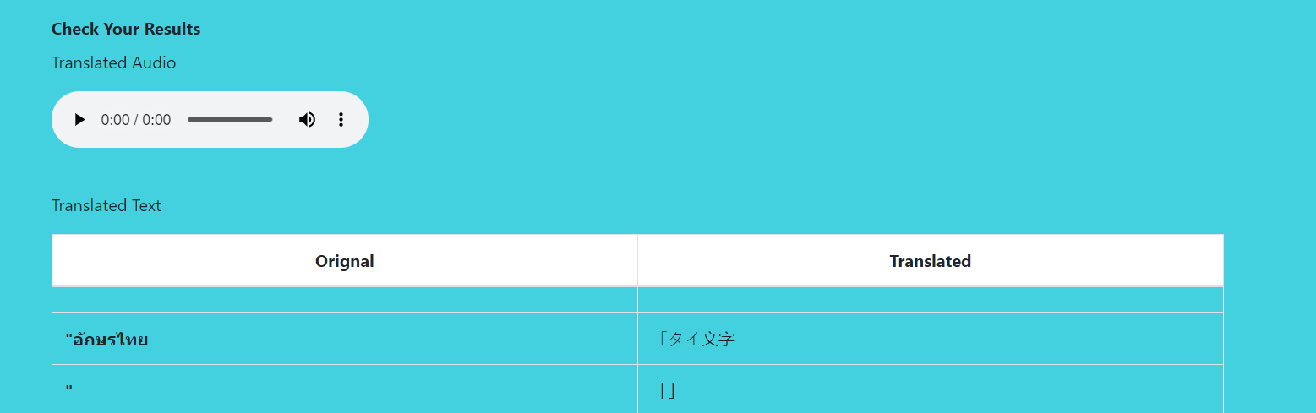

Results with Google Lens

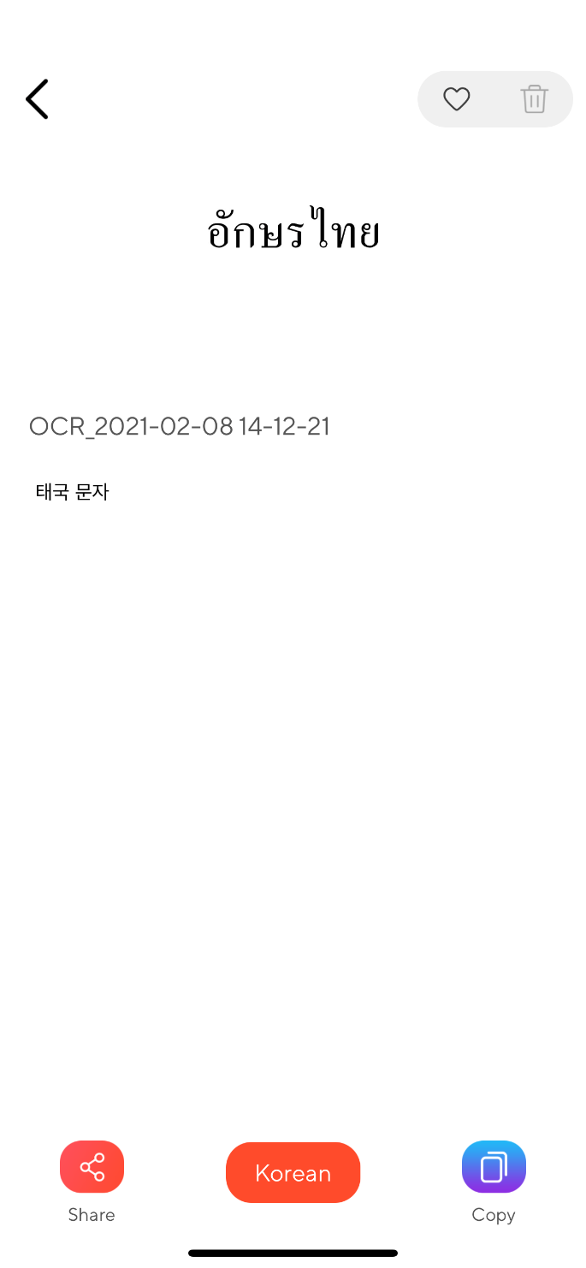 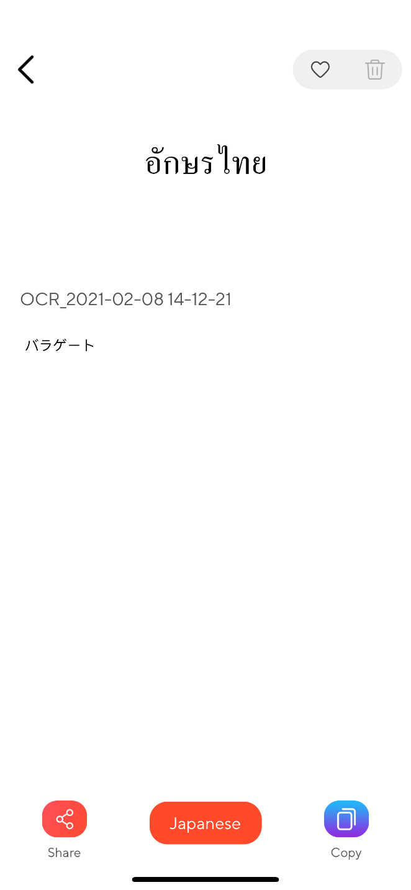

Test_image_11:

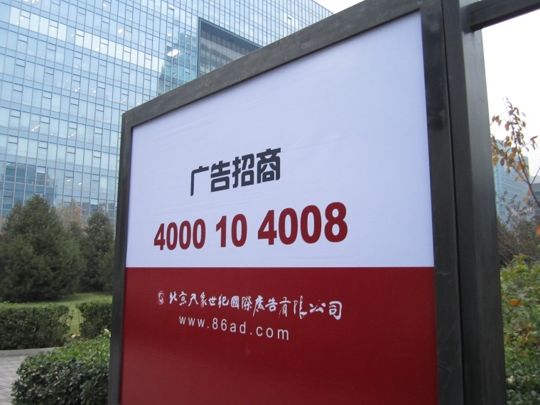

Result with our application in Korean:

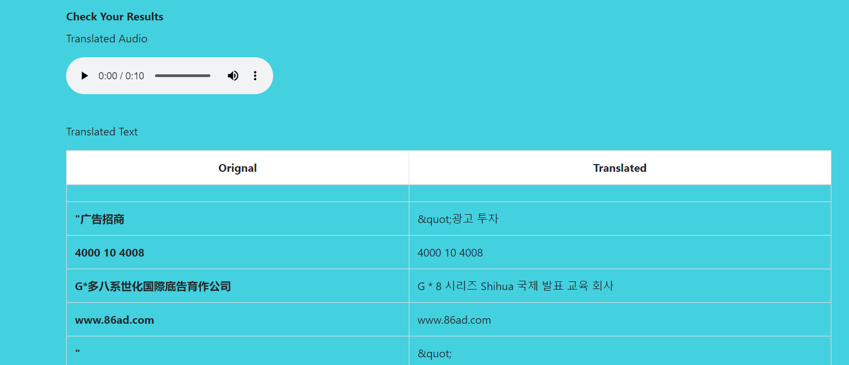

Result with our application in English: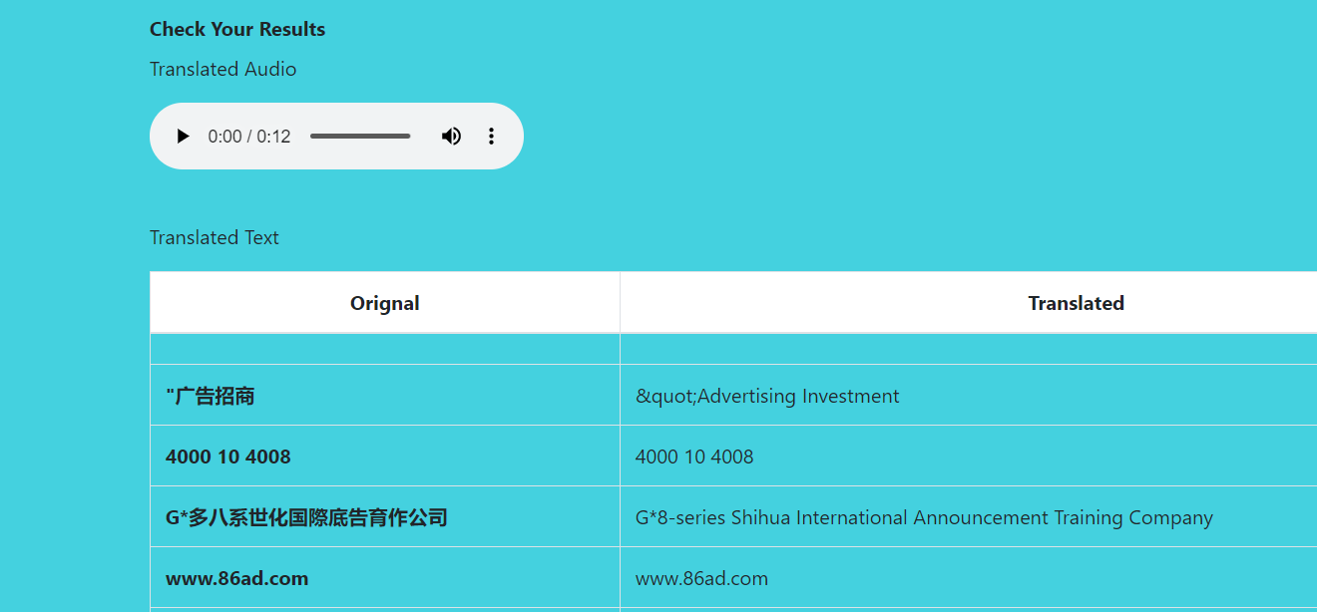

Results with Google Lens:

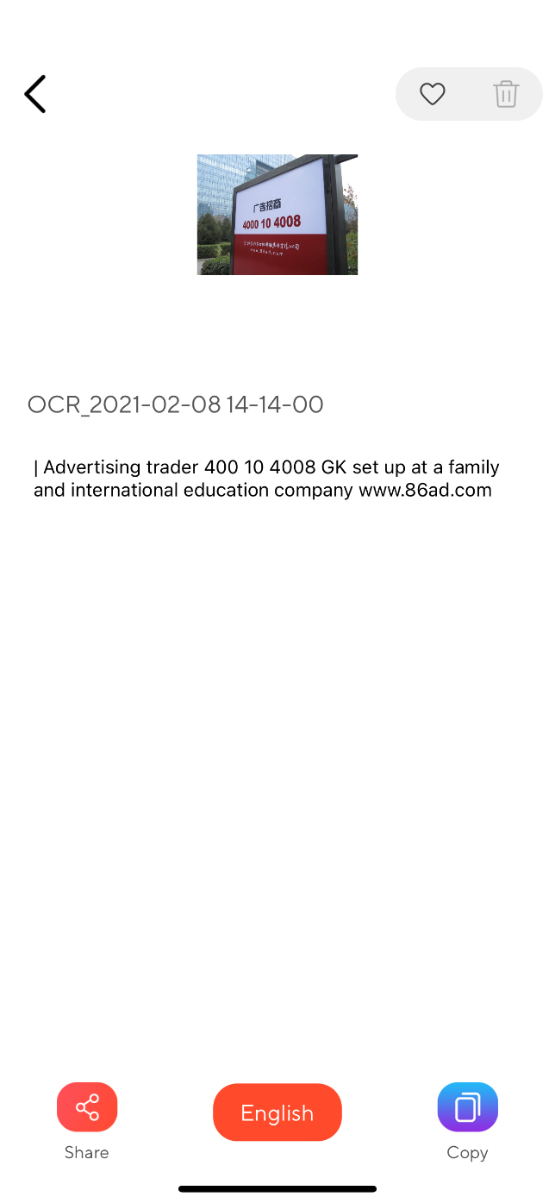 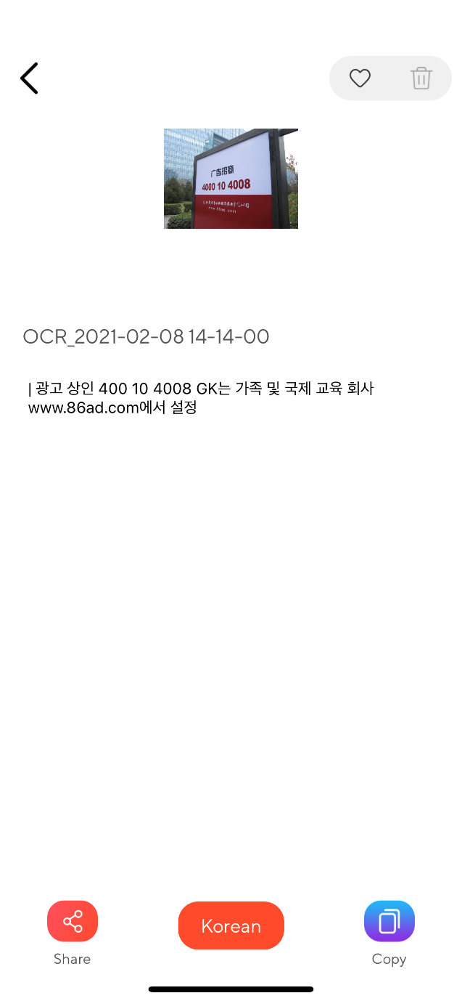

Results are not same but most of the conversion are same.

Test_image_12:

Text inside image is in Italian

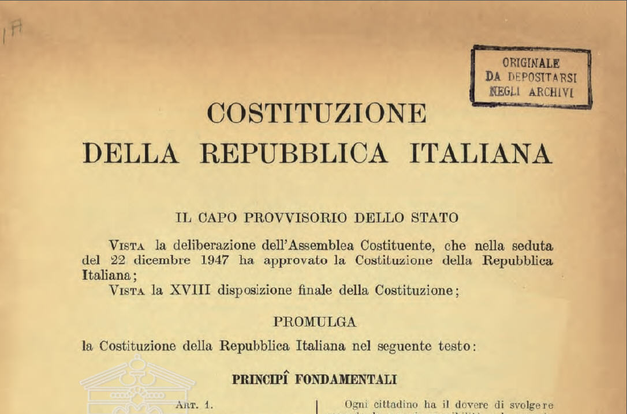

Result with our application in Japanese:

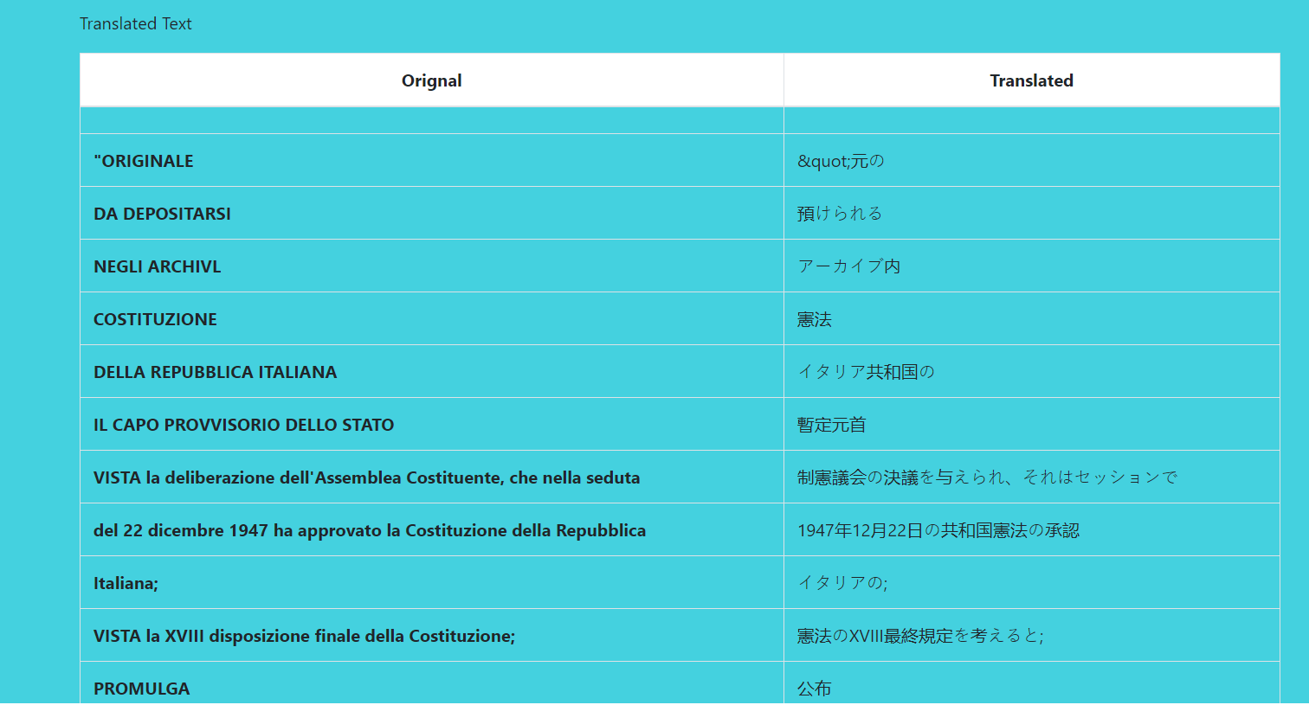

Result with our application in Hindi:

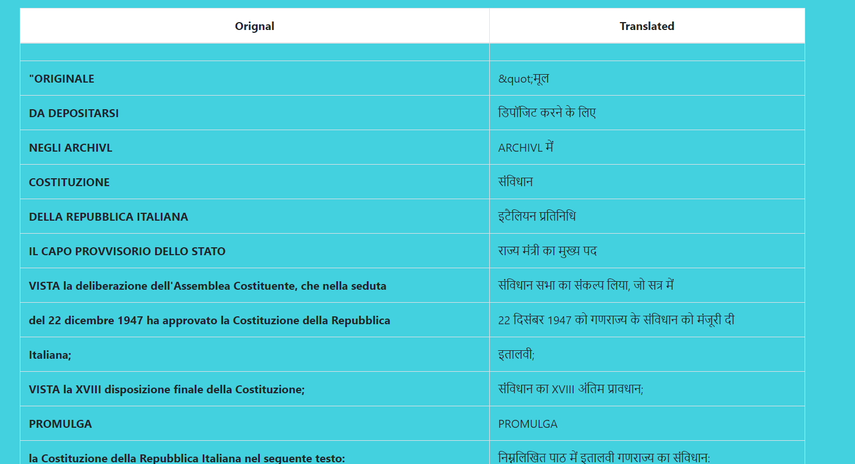

Results with Google Lens:

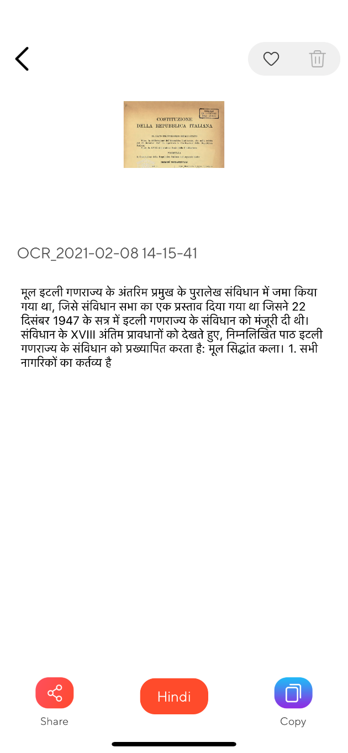 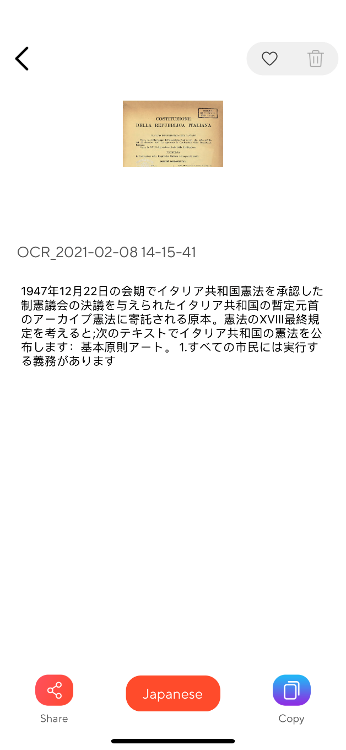

Here clearly our application is converting text line by line.

Test_image_13:

Text inside image is in Spanish

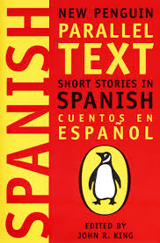

Result with our application in Hindi:

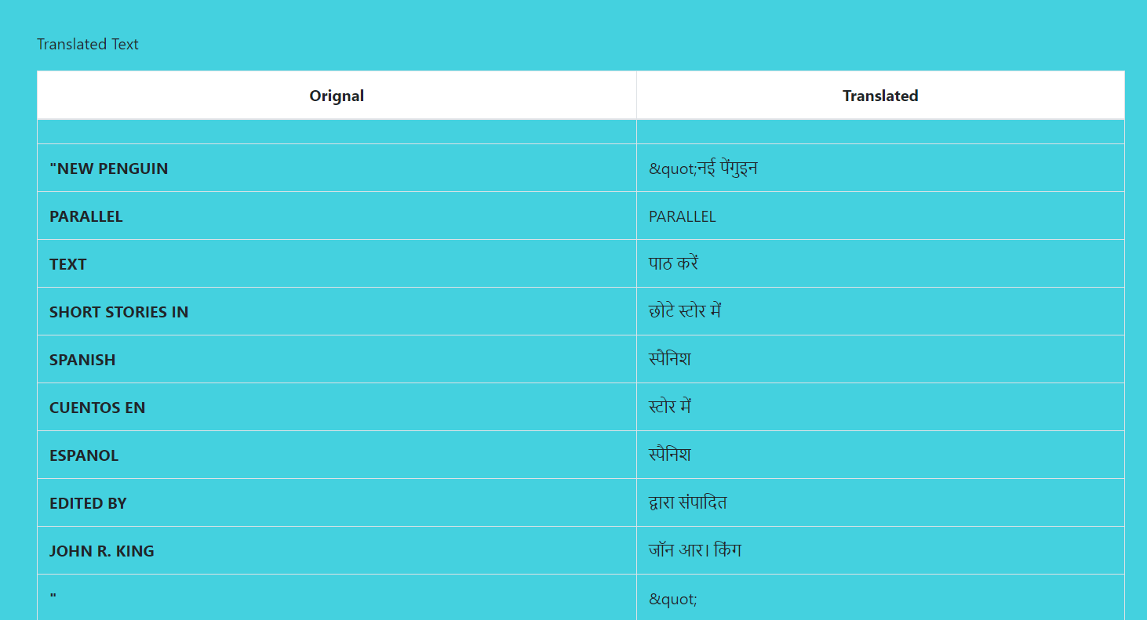

Result with our application in English: 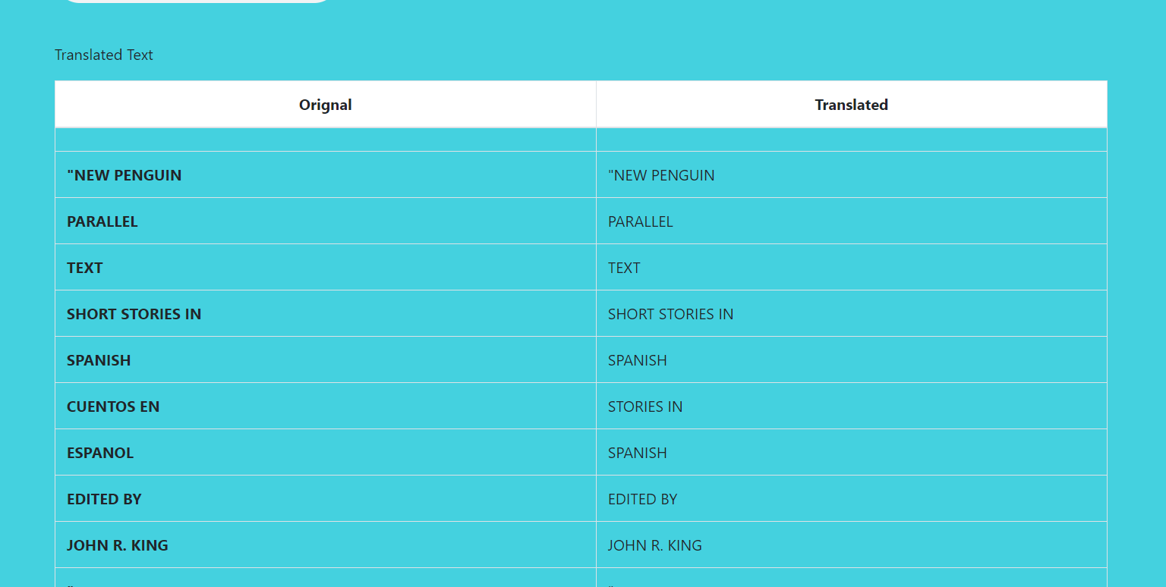

Google Lens Results:

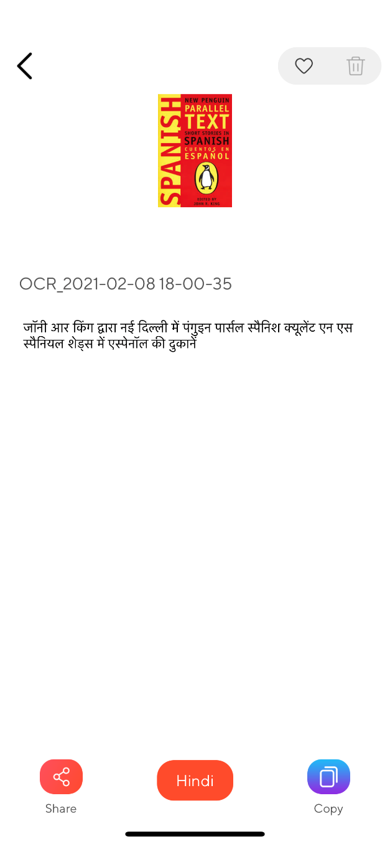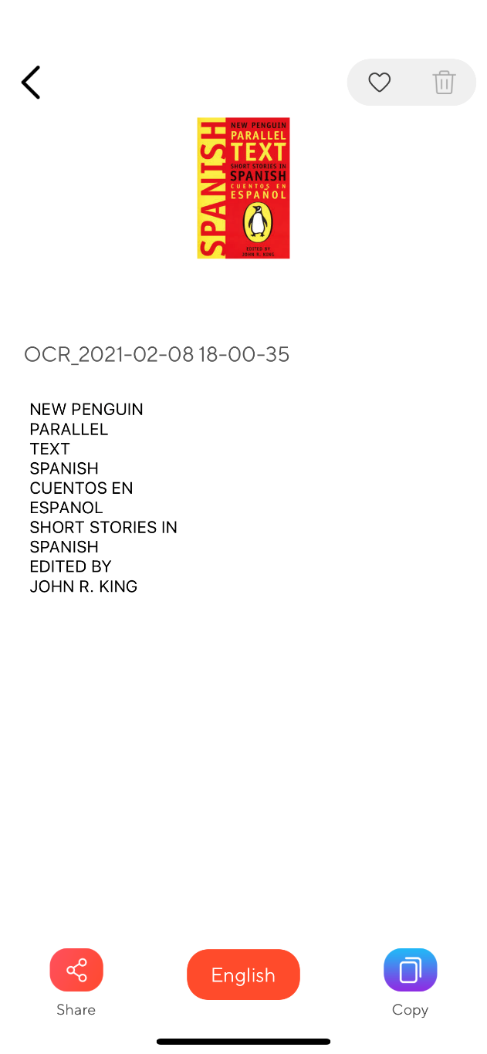

Clearly in this case translator guru (application developed by us ) is leading more better results.

Test_image_14:

Text inside image is Spanish.



Result with our application in Italian:

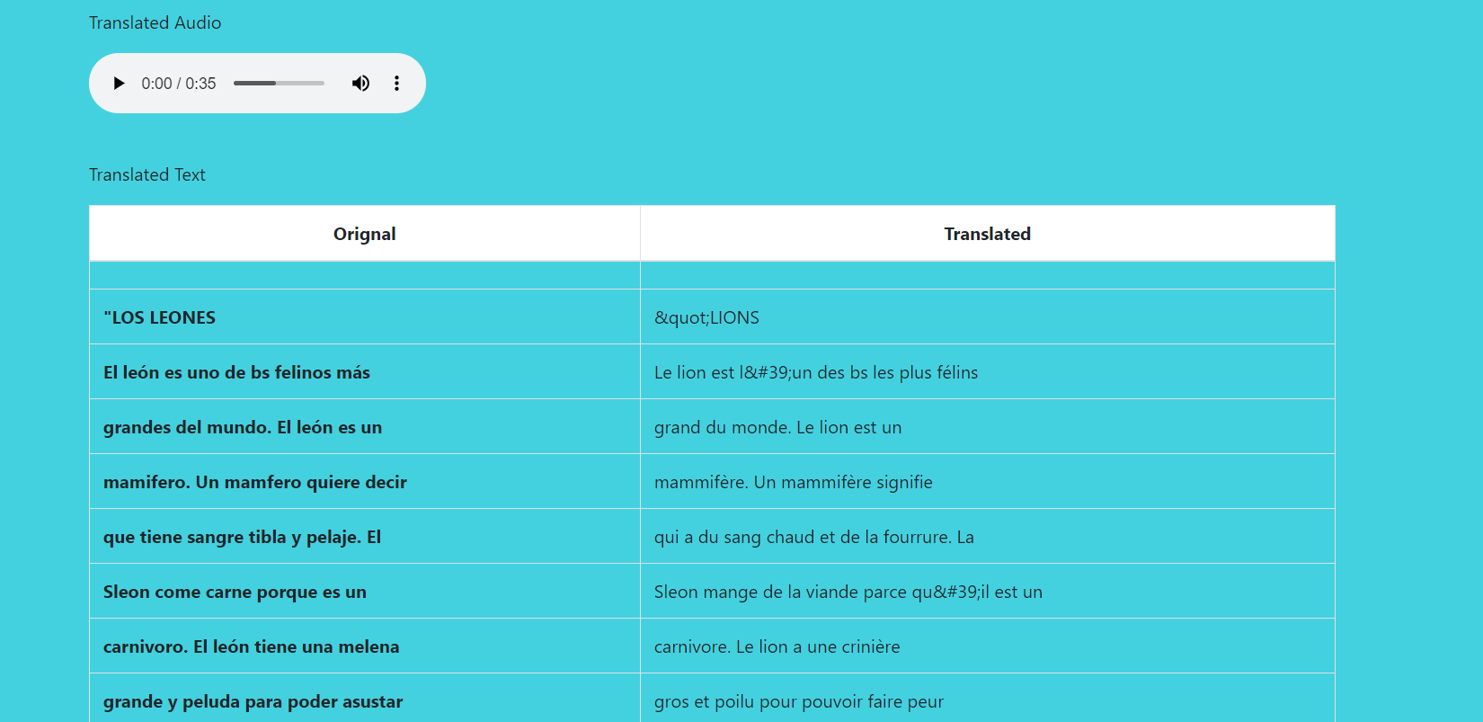

Result with our application in Hindi:

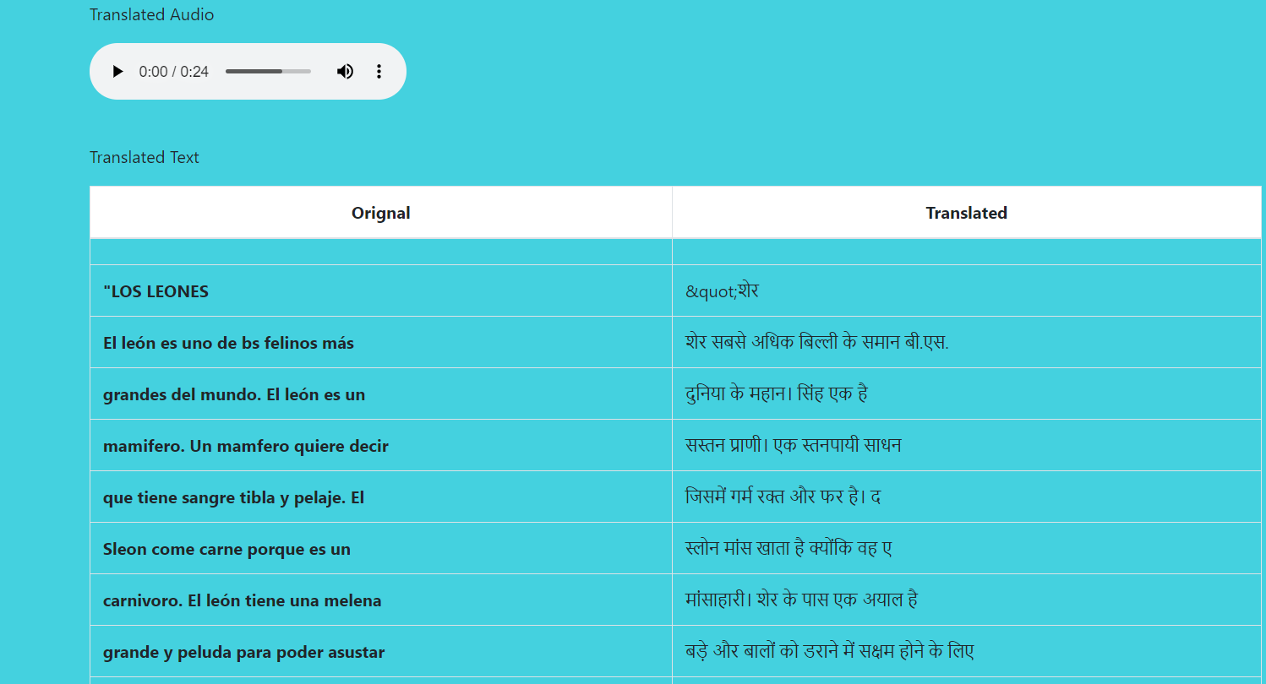

Google Lens Results:

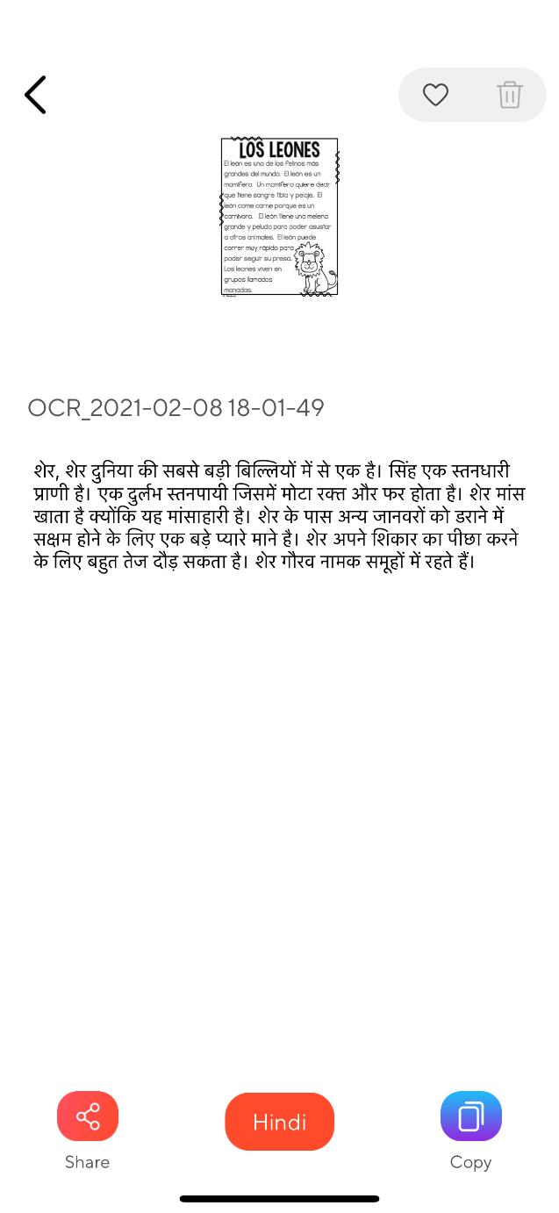 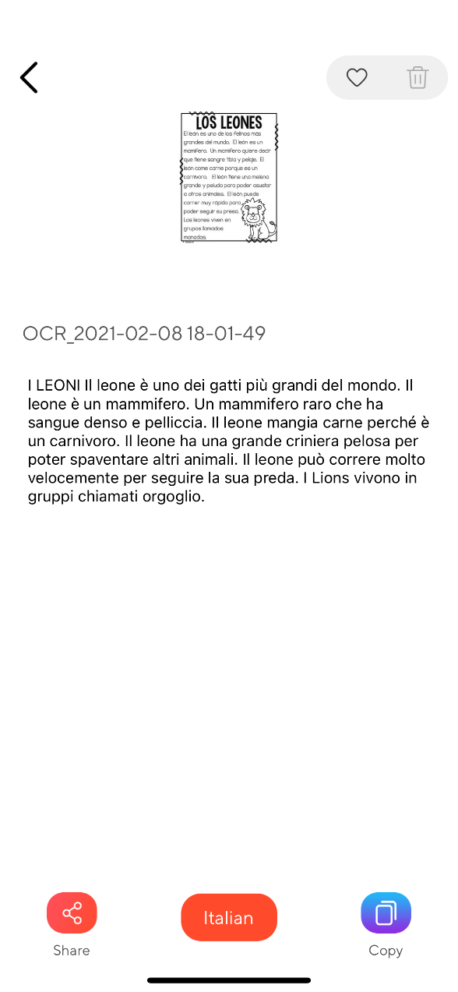

Although the Lens translation make more systematic conversion, our application exceptionally able to translate each word .

Test_image_15:

Text in image is in French



Result with our application in English:

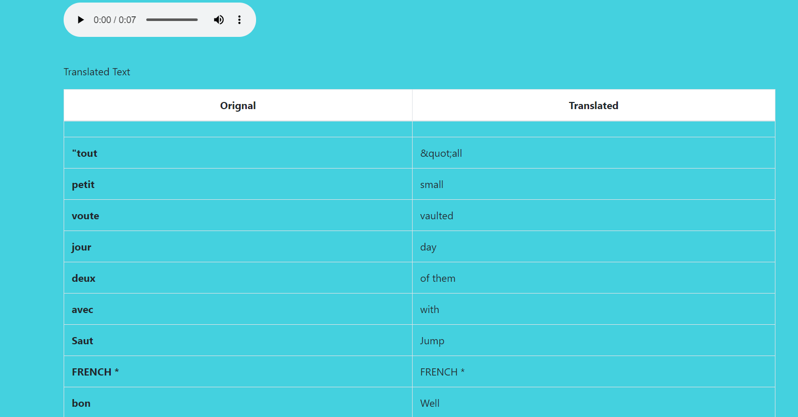

Result with our application in Chinese:

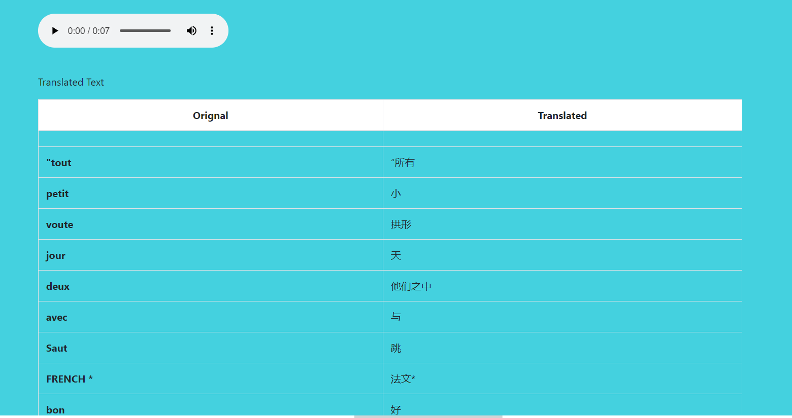

Google Lens Result:

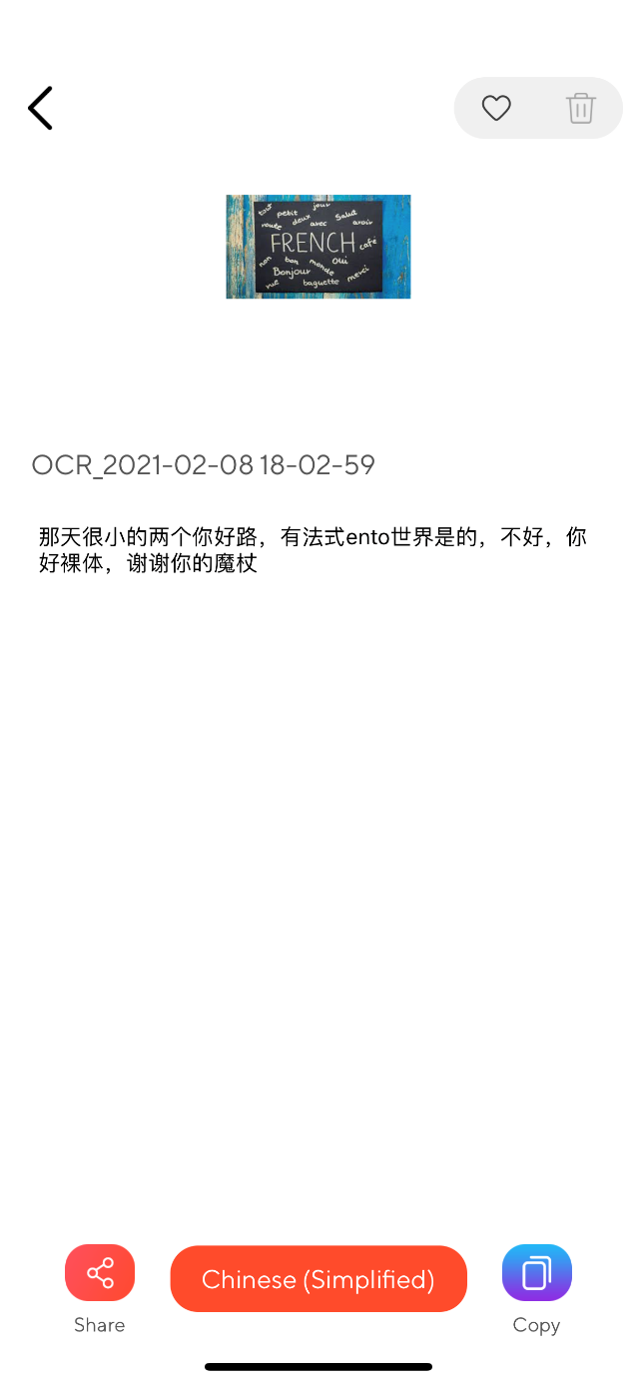 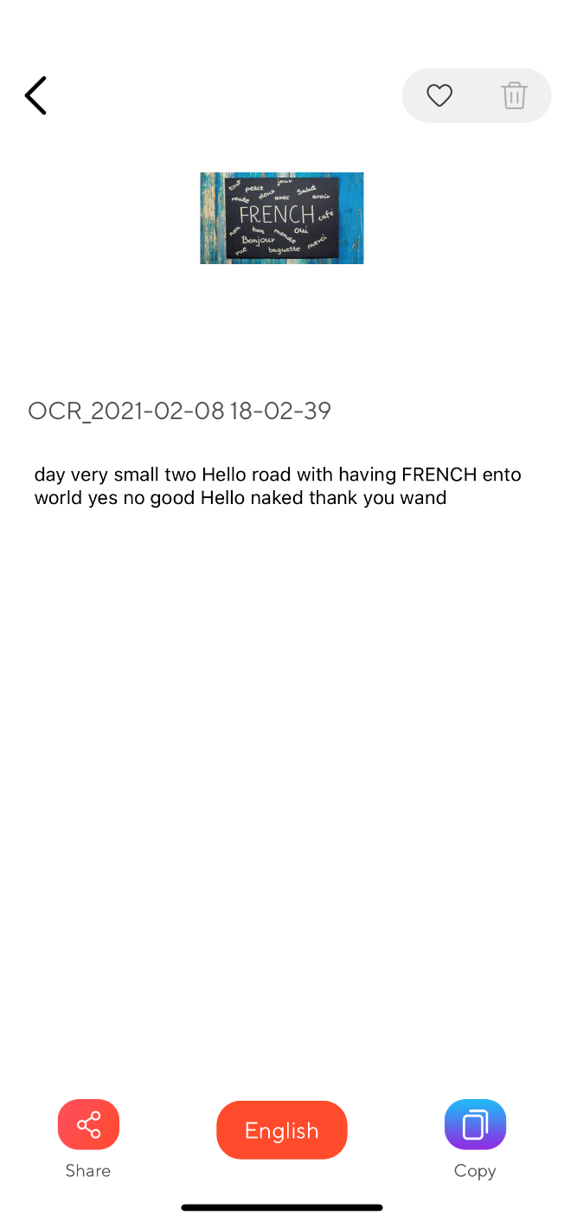

Results are same for both the app.

Test_image_16:

Image in text is in Urdu



Result with our application in Hindi:

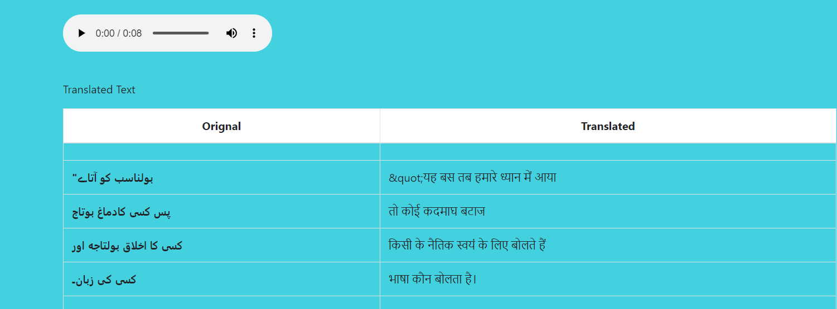

Result with our application in French:

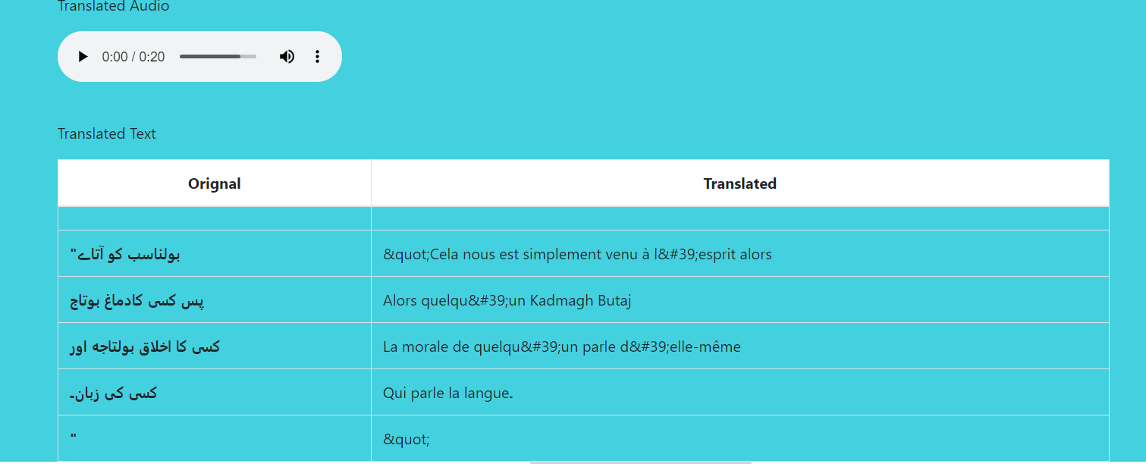

Result for Google Lens:

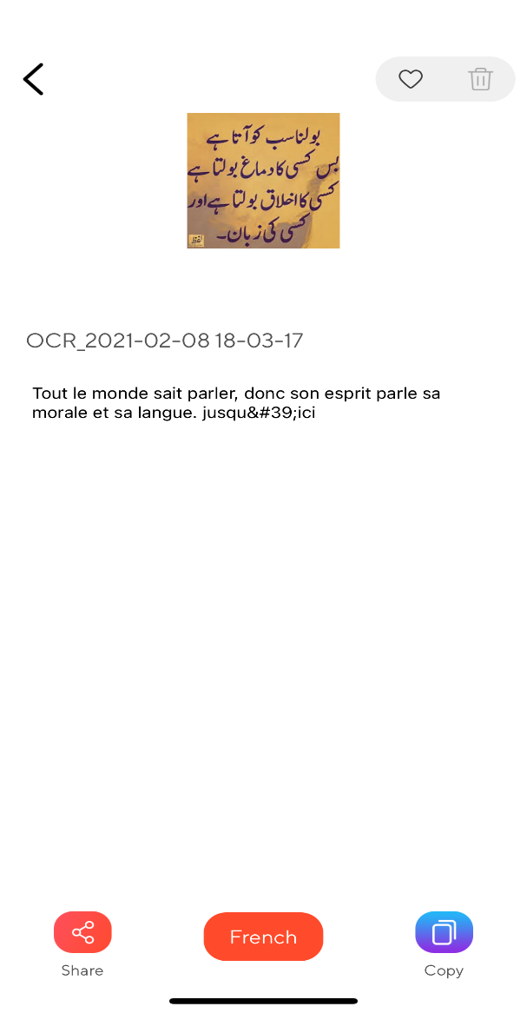 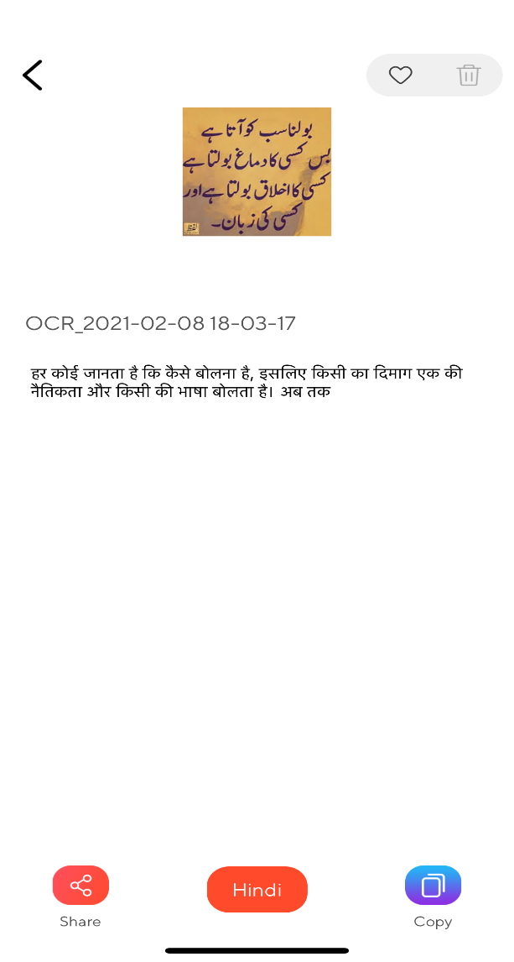

Results for both app is same.